**Lecture: Playbook Structure with YAML**

YAML is a simple markup language, but it has some specific formatting requirements that we will want to be aware of. We will look at that and show a playbook with all the major sections defined as an example.

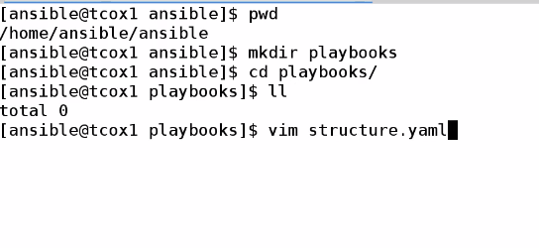

Started with

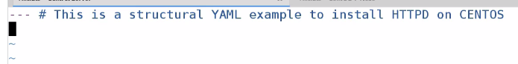

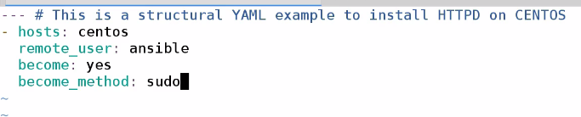

Now this whole host environment

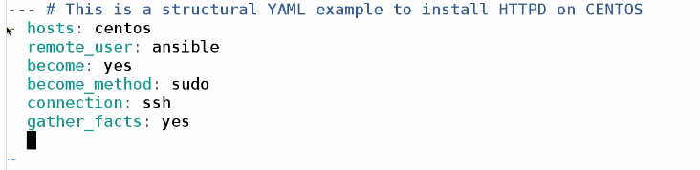

Now we gonna define variable

And major section task

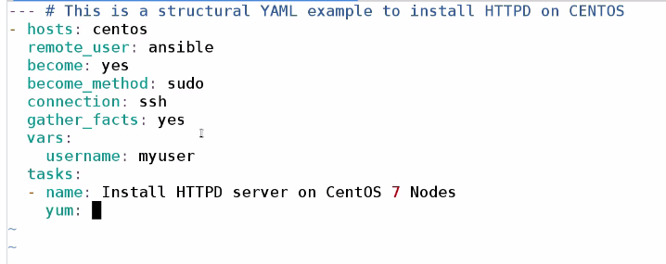

Now we goona use module

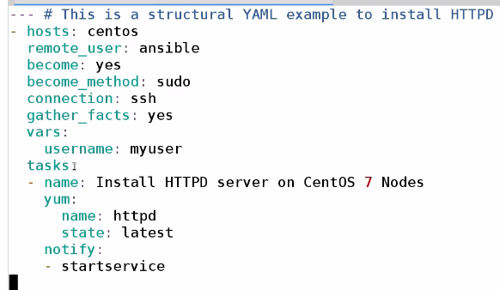

Now it is completed

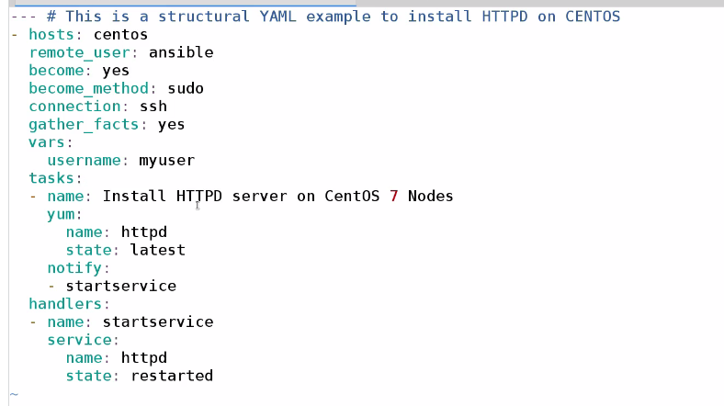

Running playbook

